1. I have a book. It´s........ book.

You have a girlfriend. It´s ......... girlfriend.

She has a pet. It´s ......... pet.

He has a car. It´s ......... car.

We have a house. It´s ......... house.

They have a big family. It´s ......... family.

1. She is ................................ (80).

I read a book ...........................(50) Shades of Grey.

My address is Športová ................................. (29).

At the airport look for the Gate ...................................(43).

1. Name: Lucy

From: Spain

Address: American St. 17

Age: 35

Marital status: single/married/divorced

Job: shop assistant

Tel. number: 0916 566 358

1. 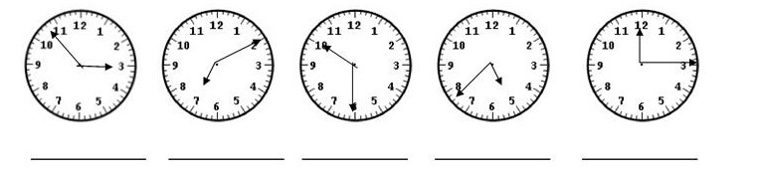
2. Plural:

key ..................... card ........................... money ............................. child............................

man.................... person........................ woman.............................. pen.............................

orange................ sandwich.................... watch................................ desk.............................

1. Where is your........now?

car ................................................................... glasses...........................................................

English book .................................................... novel.............................................................

bag................................................................... feet................................................................

1. In the shop:

otvorené ....................................... shoes:

zatvorené ....................................... colour:

ťahaj ....................................... size:

tlač ....................................... price:

1. My breakfast: ............................................................................................................................................................................................................................................................................................................

Čo ješ / piješ na raňajky?

Mám rád...

Nemám rád.....

Máš rád...........